**Solar DC Plant**

We (Maven) provide smart Solar DC solutions to our clients. We recommend these small and smart plants for rural areas and small shops where the client has less power demand.  It is a very economical solution and independent from electrical connections. We reach out to our customers and advise them of these solar solutions. We provide complete solar solutions of PV module/ Solar panel, solar charge controller and Battery Bank etc along with for all the Solar Appliances like;

* **DC LED light,**
* **DC Fans/ hybrid AC DC Fan**
* **Dc Motors**
* **DC TV**
* **DC Refrigerator**
* **and DC washing machine etc.**

**Hybrid Solar DC system**

We also offer **Hybrid Solar DC system**. In this system Solar Charge Controller is replaced with a Smart Inverter. This Smart Inverter has additional features of 2 charge controllers i.e. Solar Charge Controller and Grid Charge Controller. DC power generated from PV module is controlled by Solar Charge controller and AC power is controlled by Grid Charge controller.

This Smart Inverter is connected with Solar PV module as well as AC power supply. This Smart Inverter allows first to charge battery through PV module. During rainy season/ foggy weather or non-solar hour when voltage/current drops from preset parameter, then Inverter allows charging battery from AC power supply. In this way, Hybrid Inverter saves power. Hybrid system is very successful. This system cost is little higher than normal DC System but redundancy level is high.

**What is Solar DC Plant**

Basically, Solar PV Module generates DC power which is an unregulated power, to regulate the DC Power, Charge controller is used. Now this controlled DC power can be directly used to drive DC appliances like Fan, light, motor etc. Sometimes a battery is connected through a charge controller.

During the day time, the Charge controller charges the battery as well as gives direct power to DC appliances and during the night time or non-solar hour, battery directly gives power to DC appliances through Solar Charge Controller.

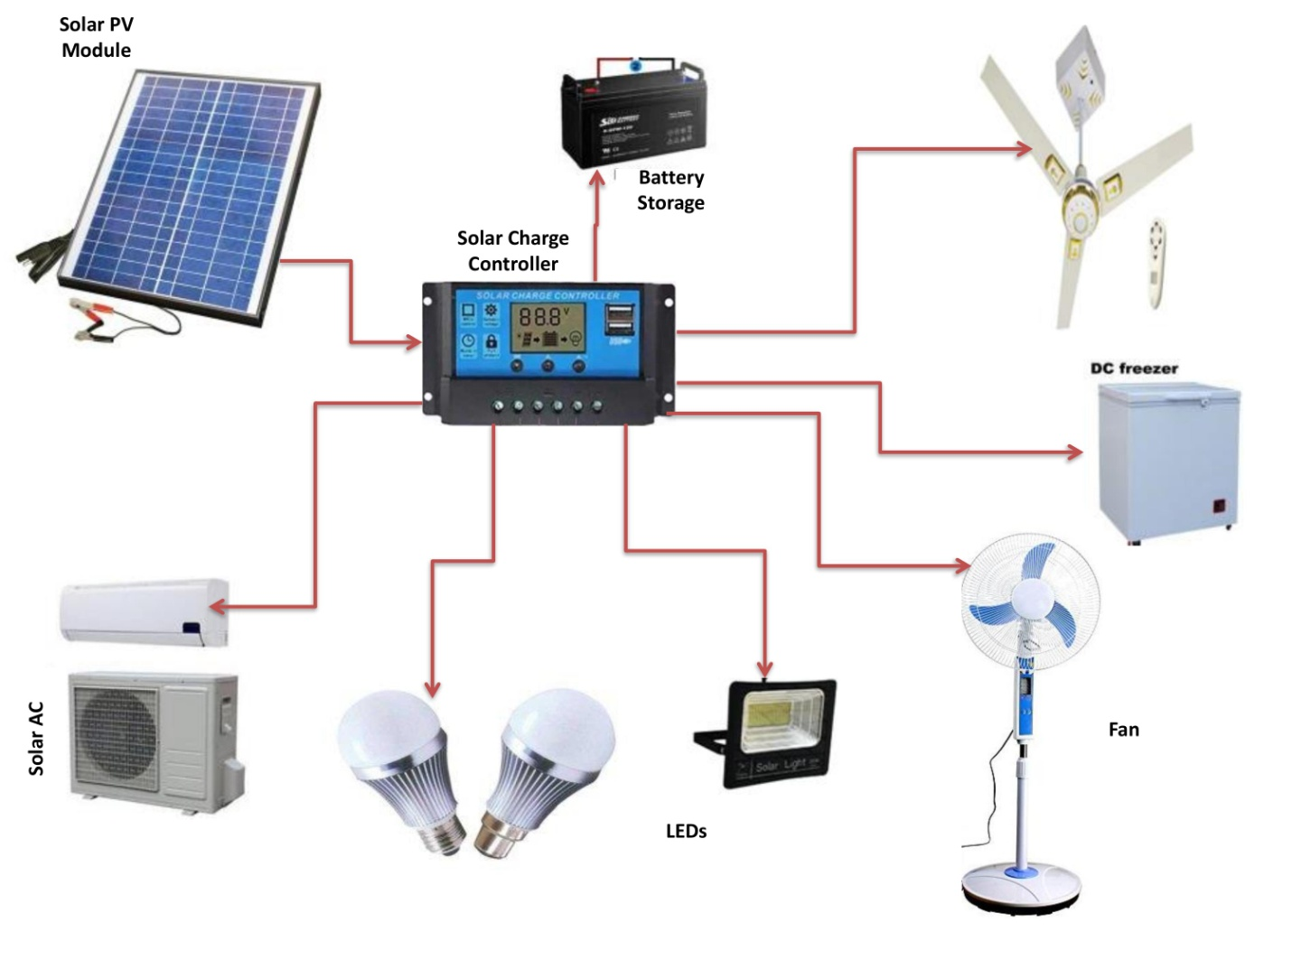

**Fig.**

**Advantages of Solar DC System;**

1.This system is very useful where frequent power cut is there or electricity is not available.

2. In Solar DC system around 70% electrical energy saving as compared to Solar AC System. Let us understand the same with an example:

We know Power (P) = V (voltage) X I (Current)

If there is 54 Inch Ceiling Fan, which DC current rating is 2.08 A and AC current rating is 0.36 A.

Solar DC Fan power consumption where DC voltage is 12 V:

P (DC) = 12 X 2.08

P (DC)= 24.96 Watt

Solar AC Fan power consumption where AC voltage is 220 V:

P (AC) =220 X 0.36

P (AC)= 79.2 Watt

With an example we can understand that DC system consumes less power than AC system

Total Energy saving = (79.2-24.96)* 100/ 79.2 %

= 68.5 %

3. Solar DC system very economical if compared with Solar AC System

4. In Solar DC Plant, Battery gives 3 times more backup than Solar DC plant.

**Components of Solar DC Plant**

1. Solar PV Module

2. Solar Charge controller

3. Solar Battery (C10, C5 etc)

4. Solar PV Module stand/ PV module structure

5. DC Appliances

6. DC Cable

**Cost of Solar DC Plant**

Cost of solar DC Plant varies from client’s requirement and also cost depends on the following factors:

1. Size of PV Module- Size of PV module depends on how much a client wants a connected load.

2. Battery backup type- Battery size increase with increase in backup time.

3. Solar charge controller Ampere rating- it depends on connected load, if load increases ampere rating increases

4. Connected Load- It depends on client that how much he/she wants to install like Number of Fan, LED Light etc.

5. Solar Stand- It depends on nos. of PV module and Size of PV Module

6. DC Wiring- As the area of house increase, DC wiring increases

**Cost of 100-watt Solar System**

We are offering following product and services

1. PV Module 100 Watt

2. PV Module stand

3. Solar Charge controller

4. DC wiring for 2 rooms

5. 2 Nos 25 Watt DC Ceiling Fan

6. 1 No 15 Watt 16-inch DC Table Fan

7. 4 Nos 5 Watt DC LED bulb

8. 48AH lead Acid Battery

9. Transportation, Installation and commissioning

**We offer in price range between 25000/- to 30000/- depends on location.**

We can also provide customized services to our customers as per their requirement.